# Main Activity Page

**Wireframe diagram:**

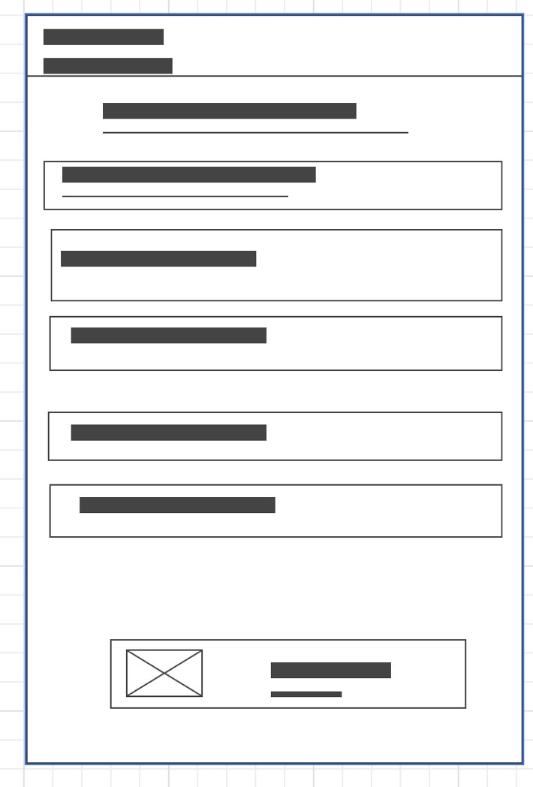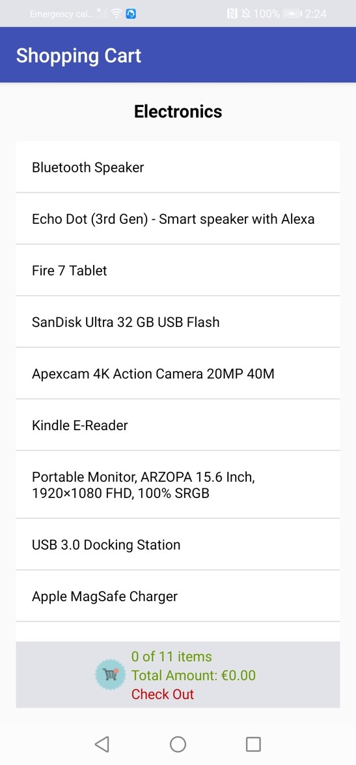

* The layout of the product page is relative. It has a page heading followed by a linear layout of products as a list.
* At the bottom of this product page, there is a container displaying number of items in cart and the total amount.
* This code is called in the MainActivity.kt class where the database is created and items are inserted using the insertMyShopItems().
* The method displayListView() fetches the name of the product and then display it on screen.
* I chose this layout as it is user friendly and understandable. I chose background colour as white with black writing so its visible.

# **StoreDatabase**

This file create a SQLite database and has methods of creating the tables, adding items to the database, adding items to the cart, finding total of product, the sum of the items in the cart.

**Detail Activity**

Wireframe of Detail Activity page

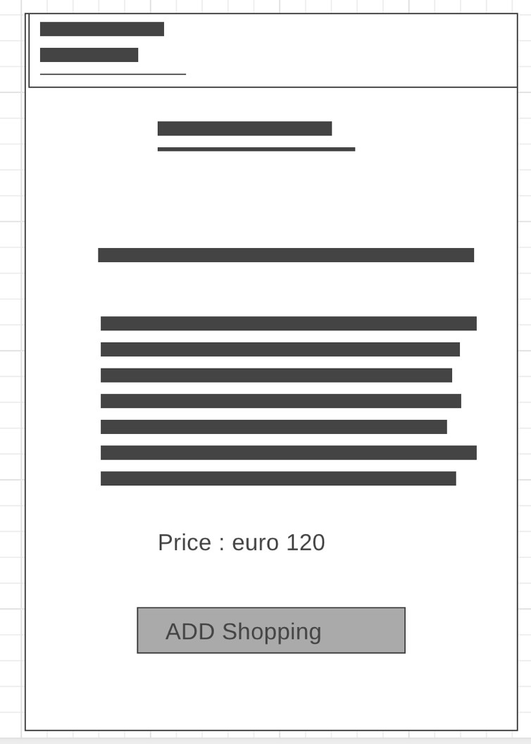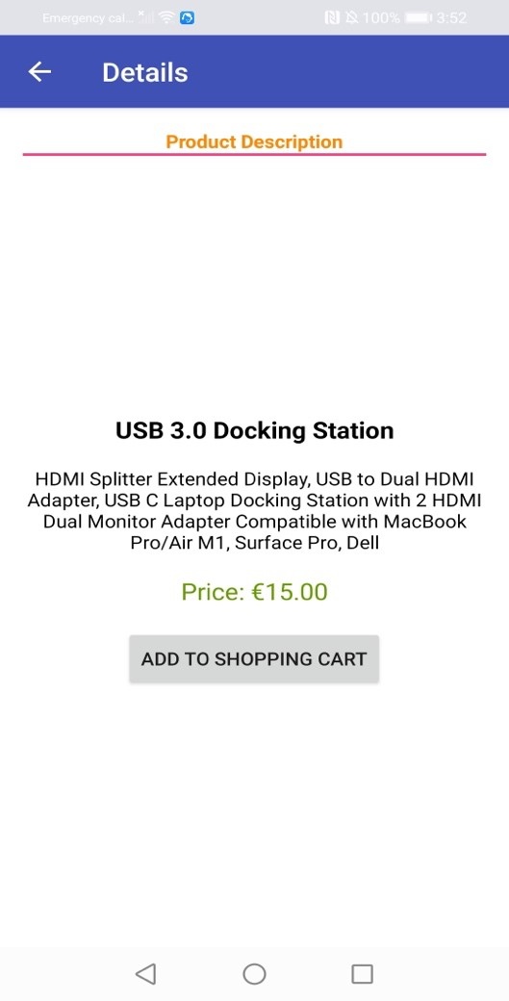

It shows the product name and its description and price. At the bottom it has a button that can add it to the cart and to checkout.

**Shopping Cart Activity**

Cart checkout wireframe:

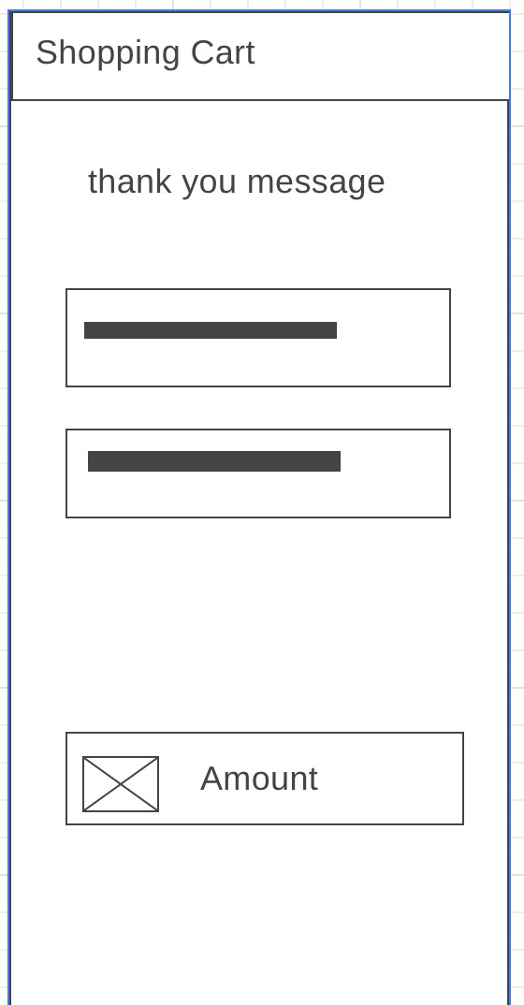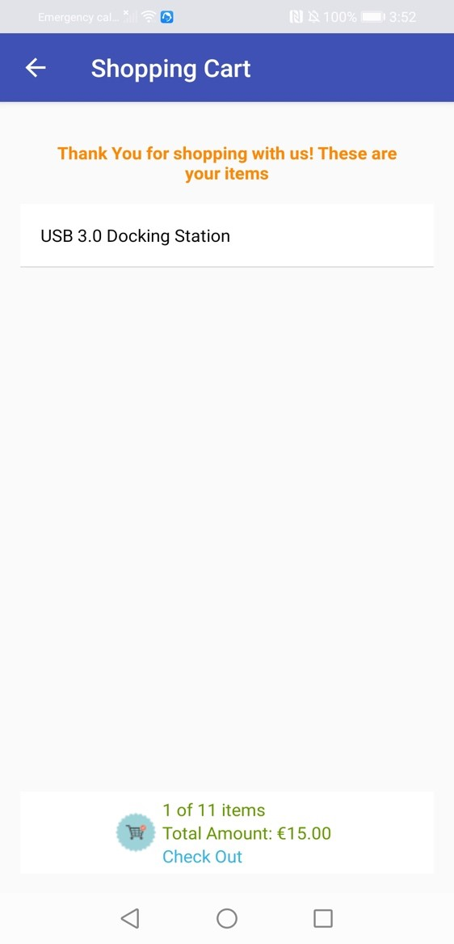

It shows a thank you message for purchasing the item and it also shows the item.